Project Name | Ticketing System | Start Date | 22/04/2025
Project Manager | |||||||, |||||||| | Prioritization | High
Owner(s) |  | Scheduled Completion Date | 27/05/2025

Purpose
The Ticketing System project will be based on finding, researching and implementing a Free Open-Source Self hosted Ticketing System for ||||||| to use as an internal IT support tool and as a platform for certain course-related assignments. With this project, a new ticketing system will meet the necessary requirements outlined by the Project Manager(s) that will ensure a long-term solution.

Scope
The Ticketing System project will encompass the finding or creation of an in-house ticket operating system that contains the Project Manager’s required features.

Objectives
- Ticketing System must have a functioning Prioritization/Reporting System
- Ticketing System must have a functioning Web Portal/Dashboard
- Ticketing System must have at least 1 ‘test’ KBA
- Ticketing System must be Free Open-Source, and can be hosted natively

Time/Decision Points
- Research and Evaluation of multiple Ticketing Systems
- Demonstration and analysis of finalists
- Initial Setup of Ticketing System
- Ticketing System Tests Started
- Ticketing System Tests concluded
- Final touch-ups / Project Wrap-up / Project Completion

Team Charter

Team Shareholders
- Michael Laprise – Team Lead, research and documentation, DBA
- ||||||||||||||||||||| – Research, documentation, system test, DBA
- ||||||||||||||||||||| – Research, Documentation, Systems Specialist
- |||||||||||||||||||||– Initial assistance, documentation and research, systems specialist
- |||||||||||||||||||||– Project Manager
- |||||||||||||||||||||– Project Manager

Roles
Team Lead – Responsible for ensuring that all team members are on-task and are working on what they are assigned.
Researcher – Responsible for researching the topic and any technical details related to it.
Document Writer – Responsible for writing documents based on the research that was done.
Systems Specialist – Knowledge of systems and networking.
Database Administrator – Knowledge of database administration.

Responsibilities

Attendance
Team members are expected to arrive on campus prior to 8:30am Monday to Friday and are to remain on-site until 4:30pm. If a team member is unable to attend at any point in time, they must notify the other team members following the communication guidelines listed below.

Communication
Any communication retaining the Ticketing System project is to be done in-workspace.
In the event a Project Managers need to be contacted, |||||||||||| is to be contacted via Outlook (||||||||||||||||||) and ||||||||||||||||| is to be contacted either, via Teams or Outlook (||||||||||||||||||||||||).

File Share
Files are to be shared in the campus netshare at \\||||||||||||\Netshare and are NOT to be kept exclusively on SharePoint. Once a document is completed, it is to be immediately moved into the appropriate location on the netshare.

Resolving Conflicts
In case of a conflict, a meeting with the group is to be held where both sides are to calmly and politely state & discuss their cases. After the cases have been started and discussed, the group will determine whether they are able to settle their differences or not. If they are, work will continue as planned. If not, the issue will be escalated to Project Managers (||||||||||||||||| and ||||||||||||||||||||).

Consequences
Failure to comply with any of the guidelines and restrictions agreed upon in this Team Charter after an issue is brought up to the Project Managers may result in dismissal from the project, or other consequences determined by the Project Managers.

Milestones
Green = Milestone Complete
Yellow = Ongoing
Milestone No. | Milestone | Mandatory/Optional | Requirement | Completion Date | Verification
001 | Project Initiation | Mandatory | Completed the project initiation document including the scope, project requirements, team members and their roles, milestones.  Ticketing systems are researched and checked if they comply with requirements | 04/25/25 | The project managers approve of a chosen ticket management system, project charter, and milestones.
002
003
004
005
006
007
008
009
010

Requirements (Must Haves) | Description | Type of Requirement
Web Portal | The system has a website that can be accessed for creating tickets by the users or accessed by staff/admins to resolve said tickets. Ideally will have a user-friendly interface | Business
Database | The system must have some sort of database that keeps track of tickets, users, staff, and much more that can be maintained and used to create in-depth analysis. | Business
Container Support | The system must have the ability to stored in a container for ease of migration, or alternatively have a quick and installation | Stakeholder
Free (Open Source) | The system must be Free (Open Sourced) as to reduce costs and prevent complications with funding. | Business
Self-Hosted | The System must have the ability to be hosted locally on the campus’ own datacenter as to reduce costs and prevent complication involved with funding – Previous Ticketing system was shut down due to funding being cut. | Stakeholder
Categorization of Tickets | The system must have a way in which, preferably, the user can define what type of issue they are having. Example: Software, Hardware, etc | Stakeholder
Assign Tickets | The system must have a way in which an admin can assign tickets to the support staff to balance out tasks or to get the user the best expert in a certain field. | Stakeholder
KBA support (Articles) | The system must be able to self-host a (multiple) KBA (Knowledge based Articles) that can be accessed by the users to see existing solutions for their particular problems. | Stakeholder
Dashboard | The system must have a clean interface in which the users or admins can see relevant data pertaining to them such as; Seeing the status of their tickets or being able to view if every ticket is being handled, what’s high priority etc | Stakeholder
Reporting | The system must have ideally a built-in analytical tool for in depth analysis that taps into the database and produces statistics or charts that are requested by the admin. Alternatively the system can have a simple analytical tool but could export data for more in-depth analysis. | Stakeholder
Prioritization | The system must have a way in which support staff or admin can assign priority to a ticket. Said priority is used to determine which ticket should be dealt with first. | Stakeholder
Security | The system must have the capabilities to implement security features that comply with NSCC standard including access control, data encryption, and audit logging where applicable. These security features can be built in from the start or added via plugins. | Business
Requirements (Nice to have) | Description | Type of Requirement
Fine-grained Permissions | It would be nice if the system had a way to set permissions for what each IT Support personnel can and can’t do. | Stakeholder
Keyword Searching | It would be nice if the system had a way to search through existing completed or on-going support tickets via a word search. | Stakeholder
Bulk user creation | It would be nice if the system had a way to create multiple accounts at once. Either for support staff or users. | Stakeholder
API Support | It would be nice if the system had a way to tap into it via third party programs through a dedicated API. This way the system can supply info out or take info in. | Stakeholder
Email Integration | It would be nice if the system had a way in which while tickets are being submitted, resolved, and replied to, that the user would receive updates through their email. | Stakeholder
Documentation | It would be nice if there were documentation created either by the makers or by other users of the system for the purpose of troubleshooting issues with the system. Additionally, if there exists a dedicated forum. | Stakeholder
Non hindrance limitations on admin or ticket caps or none | It would be nice if there were no cap on how many tickets, admins, support staff, and in general no limits that are locked behind having to pay more once you go over. | Stakeholder
Ability to deal with tickets in bulk | It would be nice if admin or support staff could mark multiple tickets at once as resolved or claim multiple at once. | Stakeholder

Analysis – Fishbone diagram:
Here’s a little analysis via fishbone diagram demonstrating the purpose of looking for an alternative system that is Free (Open Source), and self-hosted
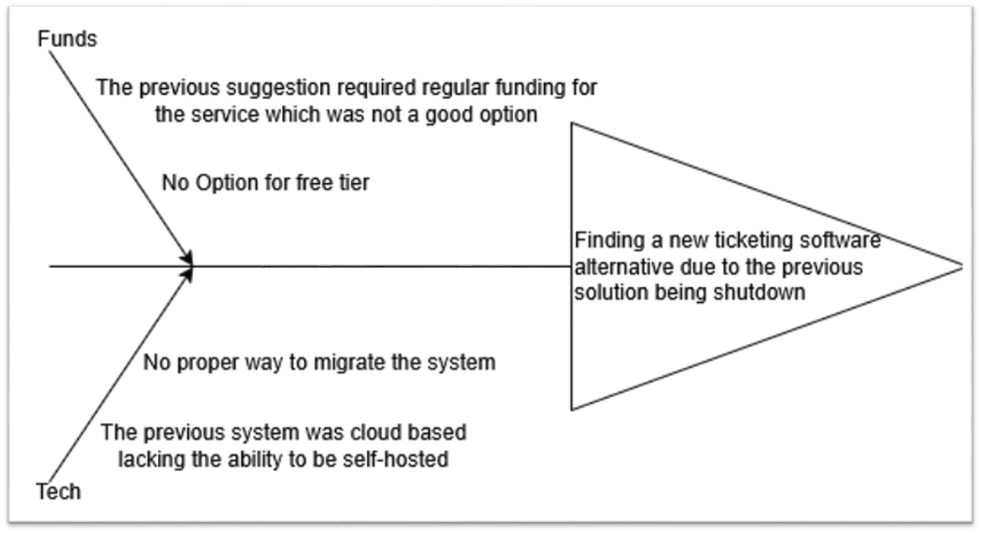

Workflow – User Experience:
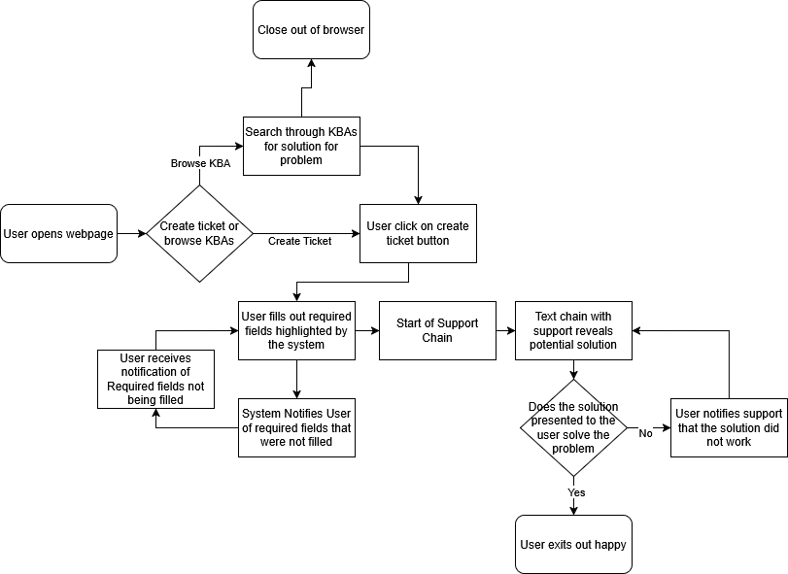

Workflow - Support Staff Experience:
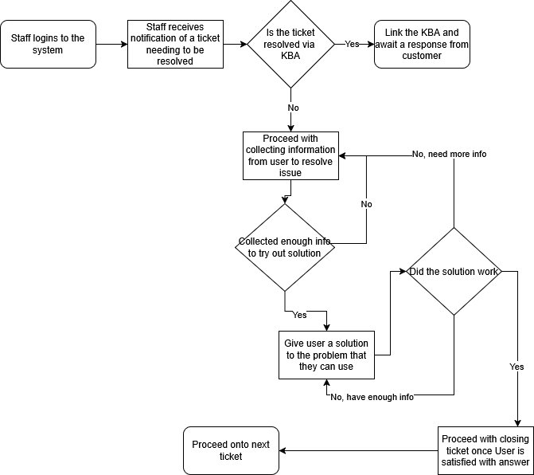

Glossary:
KBA: Knowledge Based Article – a collection of articles written for the purpose of storing known solutions to problems for quick and easy access.

